CS5590-0003: web/cloud/mobile programming

Lab 1: Multi-Page Responsive Website: e-commerce web application

Fall 2018

UMKC

Kim-Ndor Djimadoumngar

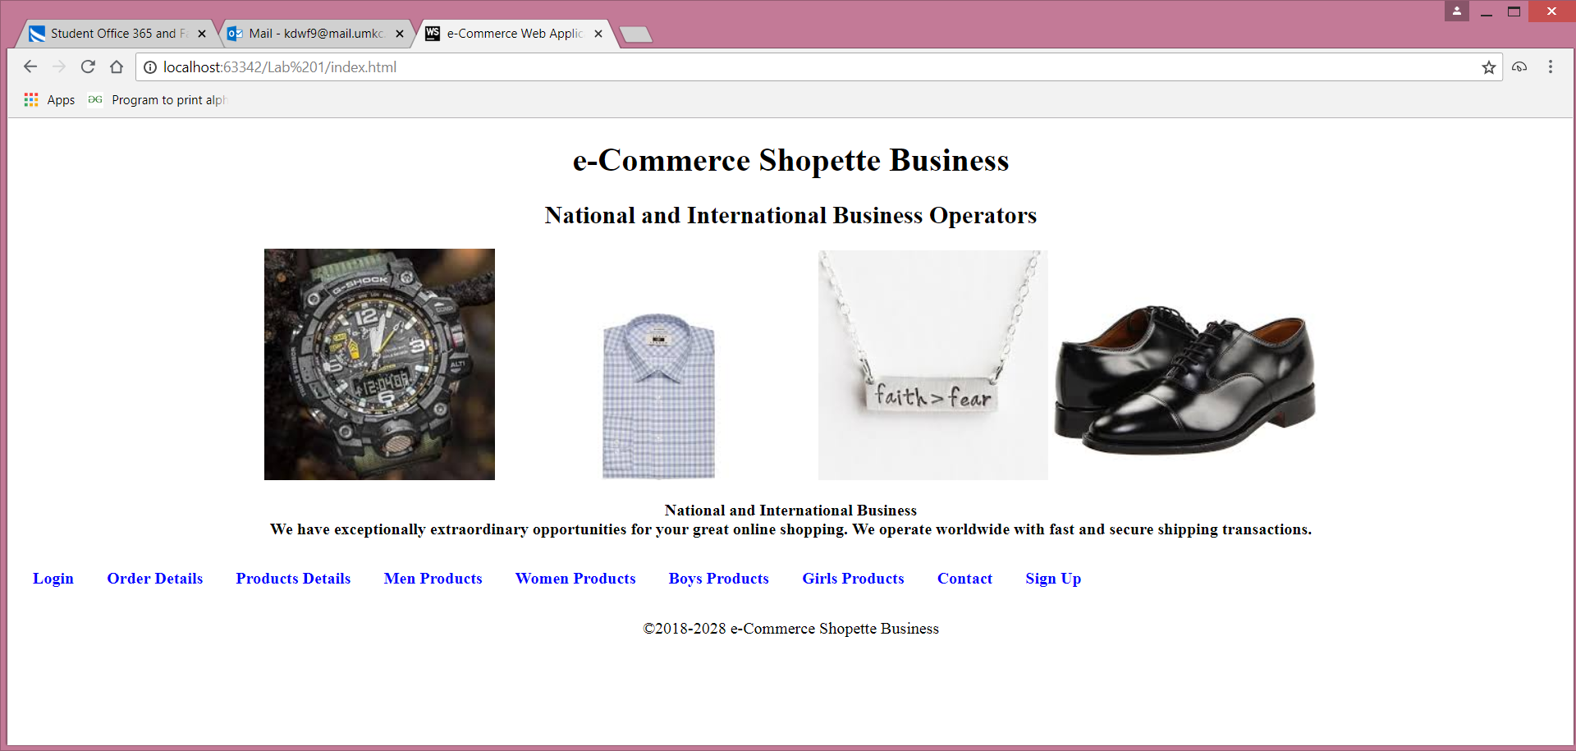

1. **Introduction**

The cloud computing system helps connect sites that distant from each other. The cloud or utility storage provides opportunities to maintained, operate, and manage stored data from remote servers. The advent of the internet and the development of the cloud system become an opportunity to make online businesses. They have helped reach stored data in remote cities, countries, and continents giving access to the global markets electronically or e-commerce. The e-commerce is has become a big business that is growing exponentially and expanding worldwide. Commercial companies can have their representatives in any parts of the world where there is access to the internet and make trades through their websites.

Websites are the interfaces between clients and producers and/or distributors. They help show credibility of a company as well as market the business to clients from distant locations. In addition, websites are accessible and convenient to all the consumers for a relatively low access cost. They are means to reach faster a great number of people and make money online without huge investments on physical infrastructure (DOGULIN digital, 2018; LYFE MARKETING, 2018). This current lab is to build an e-commerce website for a company named Shopette Business, to trade of manufactured items such as clothing, shoes, and watches, etc.

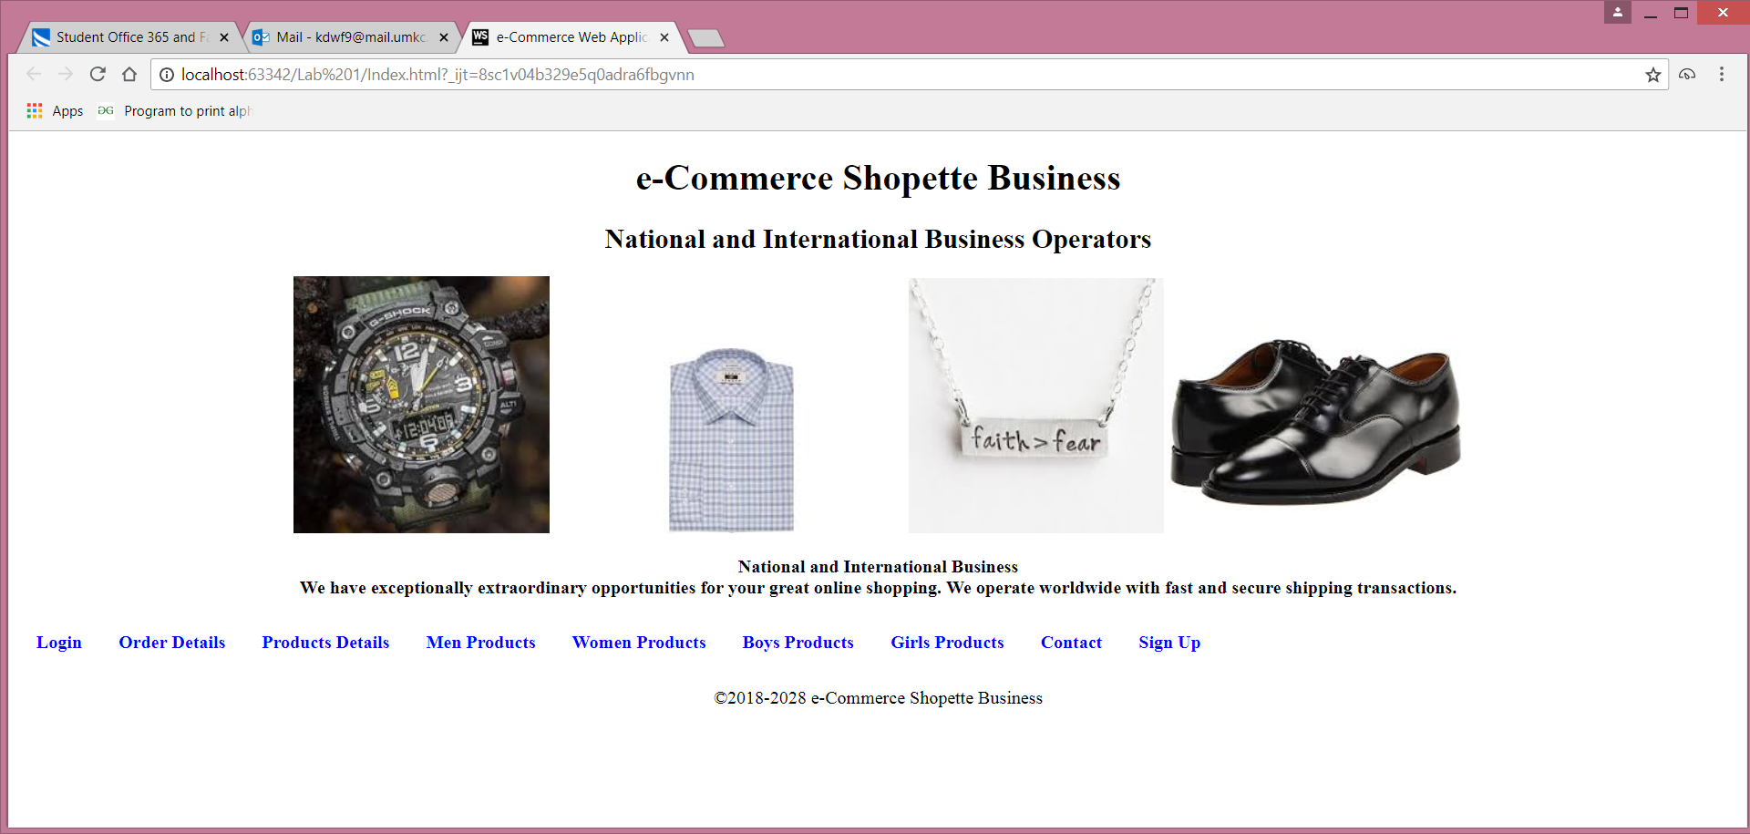

<!DOCTYPE html>  
<html>  
<head>  
 <link rel="stylesheet" type="text/css" href="mystyle1.css">  
<title>e-Commerce Web Application</title>  
 <style>  
 ul {  
 list-style-type: none;  
 margin:0;  
 padding:0;  
 overflow: hidden;  
 backgroung-color: #333;  
 }  
 li {  
 float: left;  
 }  
  
 li a {  
 display: block;  
 color: blue;  
 text-align: center;  
 padding: 14px 16px;  
 text-decoration: none;  
 }  
 li a:hover:not(.active) {  
 background-color:111;  
 }  
 .active {  
 background-color: #000080;  
 }  
 </style>  
</head>  
  
  
<body>  
  
<h1 align="center"><strong><strong>e-Commerce Shopette Business</strong></strong></h1>  
  
<h2 align="center"><strong><strong>National and International Business Operators</strong></strong></h2>  
  
<p align="center"><img src="watch.jpg" /> <img src="shirt.jpg" /><img src="jewelry.jpg" /> <img src="shoe.jpg" />  
  
<p align="center"><strong>National and International Business<br/> We have exceptionally extraordinary opportunities for your great online shopping. We operate worldwide with fast and secure shipping transactions.</strong>  
  
<ul align="center">  
 <li><strong><a href="Login.html">Login</a></strong></li>  
  
 <li><strong><a href="Order.html">Order Details</a></strong></li>  
   
 <li><strong><a href="Product.html">Products Details</a></strong></li>  
  
<li><strong><a href="Men.html">Men Products</a></strong></li>  
  
<li><strong><a href="Women.html">Women Products</a></strong></li>  
  
<li><strong><a href="Boys.html">Boys Products</a></strong></li>  
  
<li><strong><a href="Girls.html">Girls Products</a></strong></li>  
<li><strong><a href="contact.html">Contact</a></strong></li>  
<li><strong><a href="signup.html">Sign Up</a></strong></li>  
  
</ul>  
</p>  
  
<div class="footer">  
 <p align="center">&copy;2018-2028 e-Commerce Shopette Business</p>  
</div>  
</body>  
</html>

1. **Objectives**

The general objective of this lab assignment is to create a multipage responsive website. Specifically, the tasks are to create an e-commerce web application to sell, nationally and internationally, clothing, shoes, watches.

1. **Approaches/Methods**

To perform the tasks, we used the platform Webstorm. We created Html and CSS files to make the website.

1. **Workflow**

The workflow of the different units (object) of the websites is as follows:

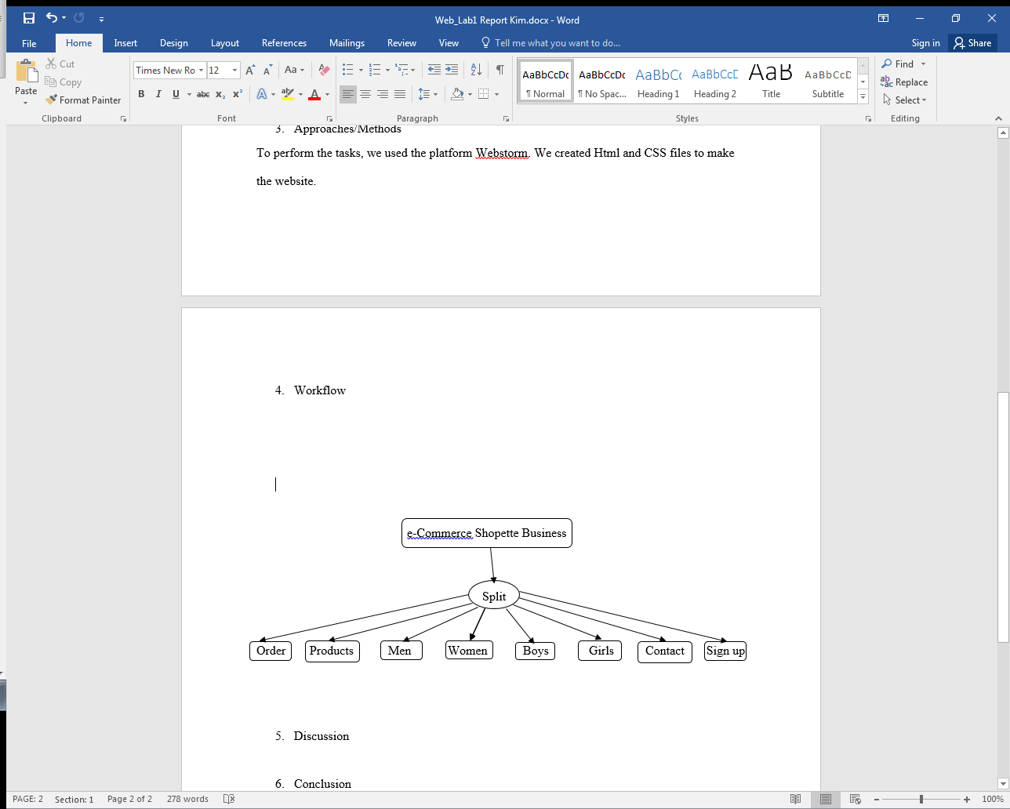

The homepage button at the end of each page brings back to the interface home. Within each category, there is a checkout button to place an order.

1. **Discussion**

This website was built using Html and CSS pages. The different tabs are Order (order details), Products (product details), Men (men products), Women (women products), Boys (boys’ products), Girls (girls’ products), Contact (how to contact e-Commerce Shopette Bussiness). The products are clothing, shoes, and watches. Each category (Men, Women, Boys, and Girls) has almost the same products. The Homepage button at the end of each page sends back to the homepage. The Order, Men, women, Boys, and Girls pages have, in addition, Place Your Order button that takes to the Checkout Form to order items. The Checkout Form has three accepted cards (Visa, Mastercard, and Discover). Each page is integrated to another making a flow between all the pages; this gives to the website a dynamic flow among all the pages for an interactive access.

**Login Page**

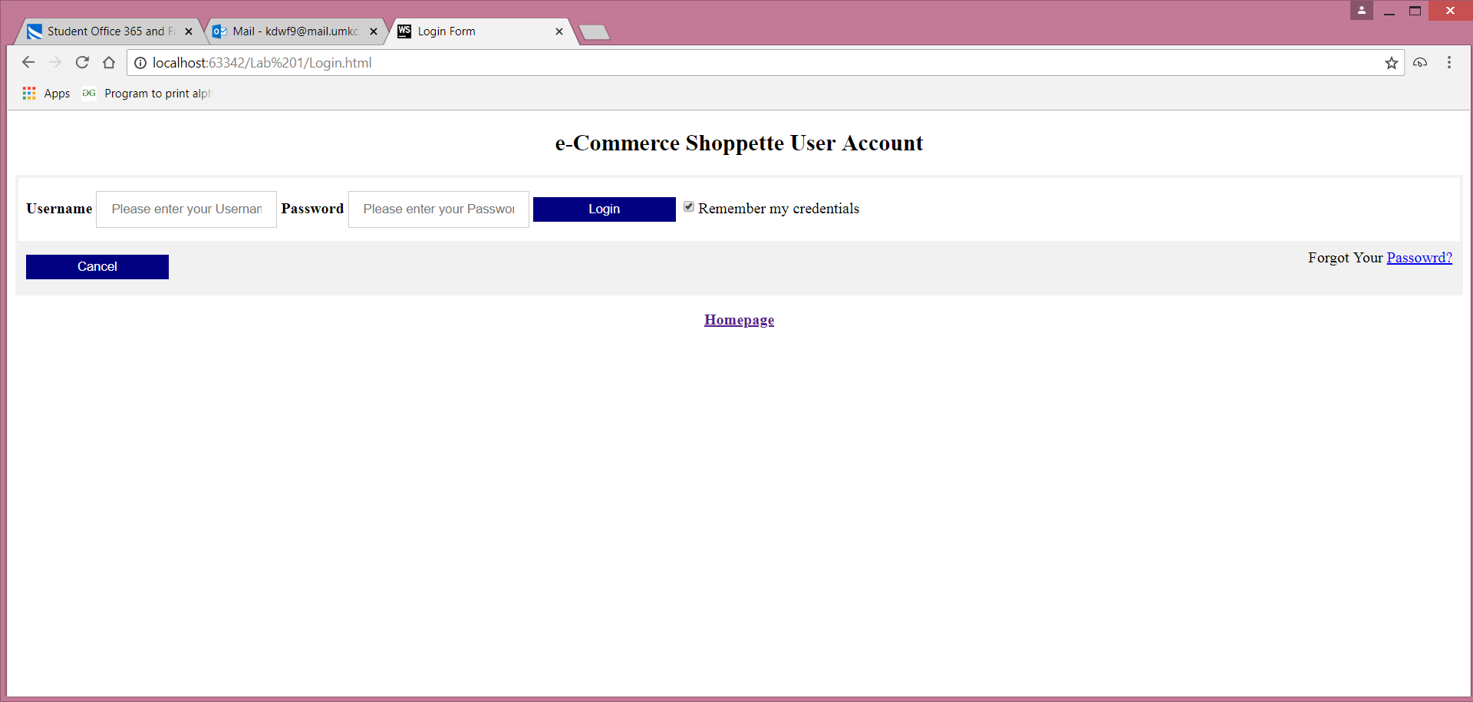

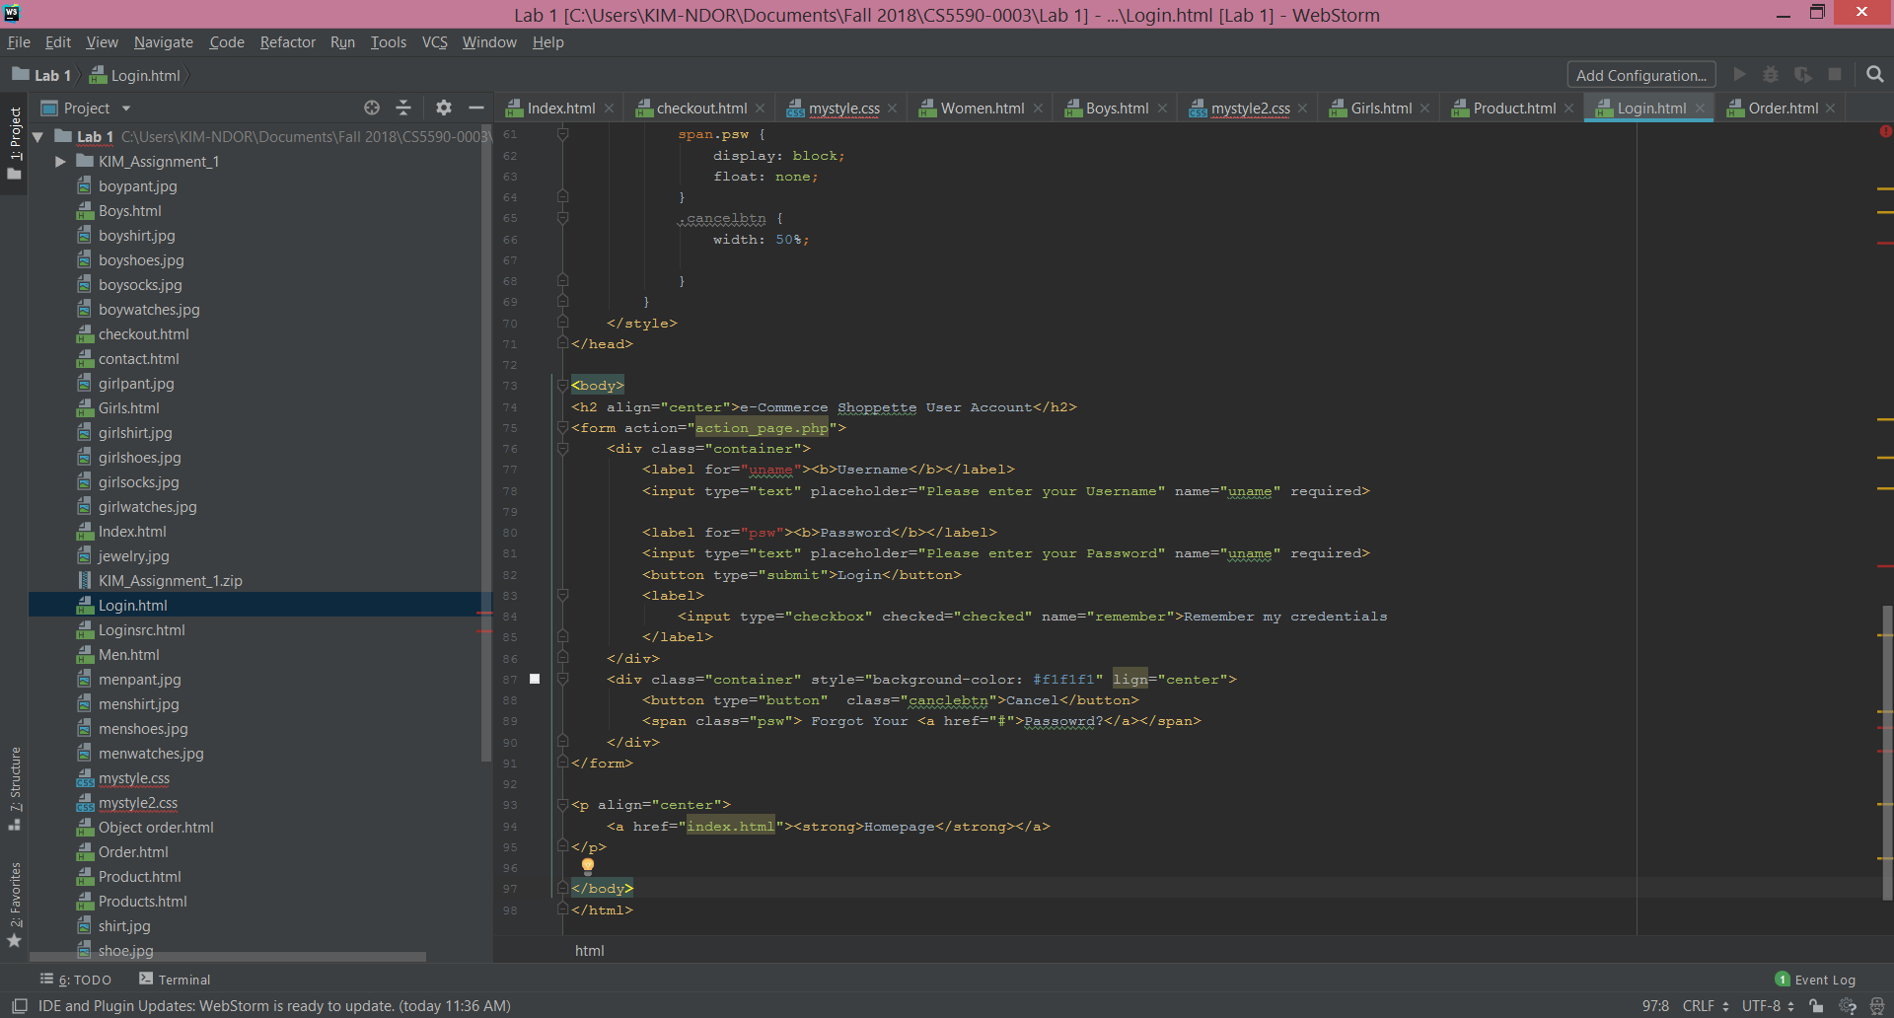

**Products page**

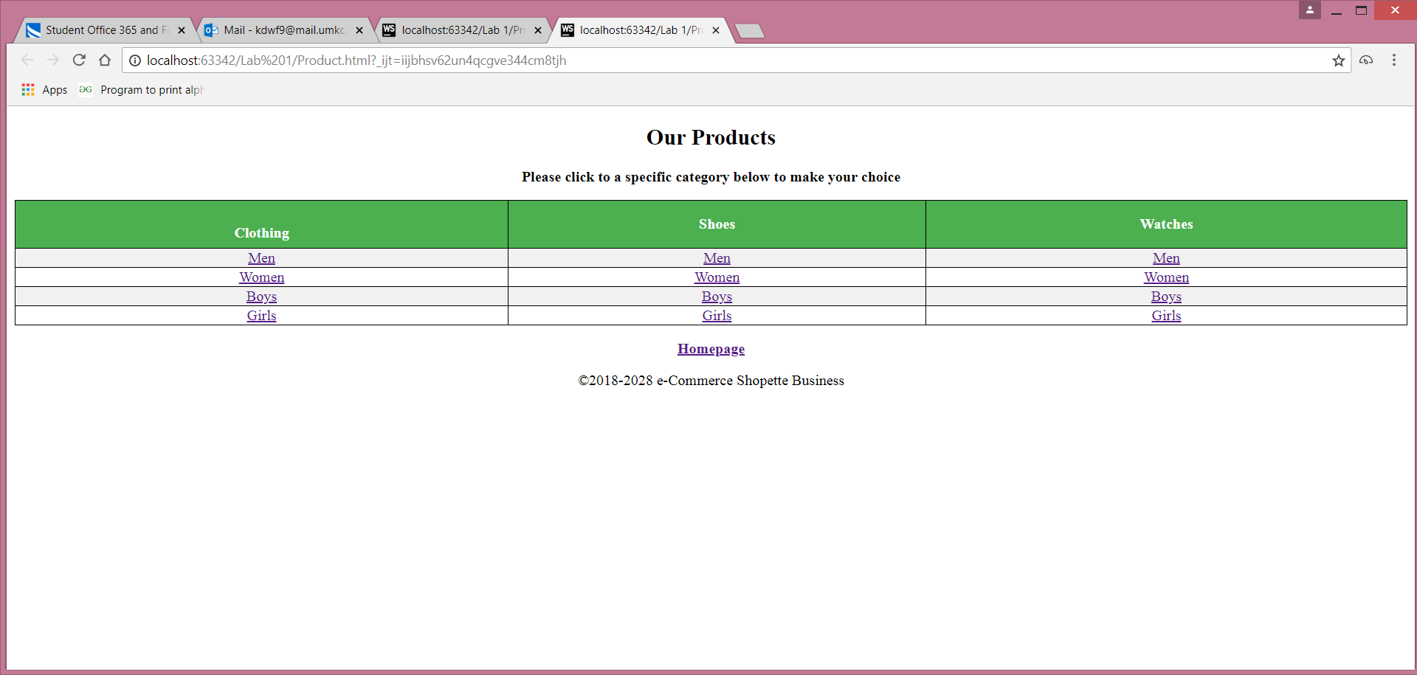

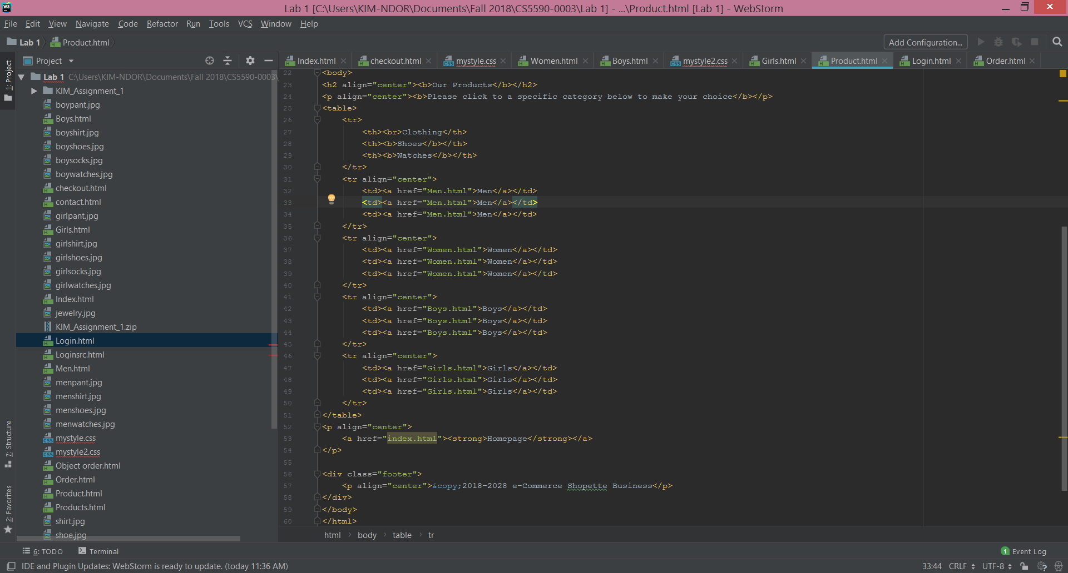

**Men Page**

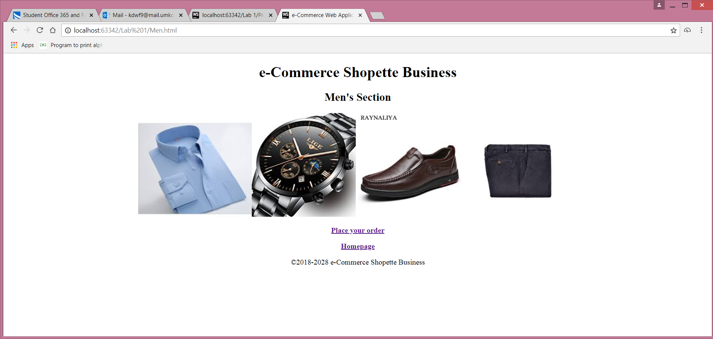

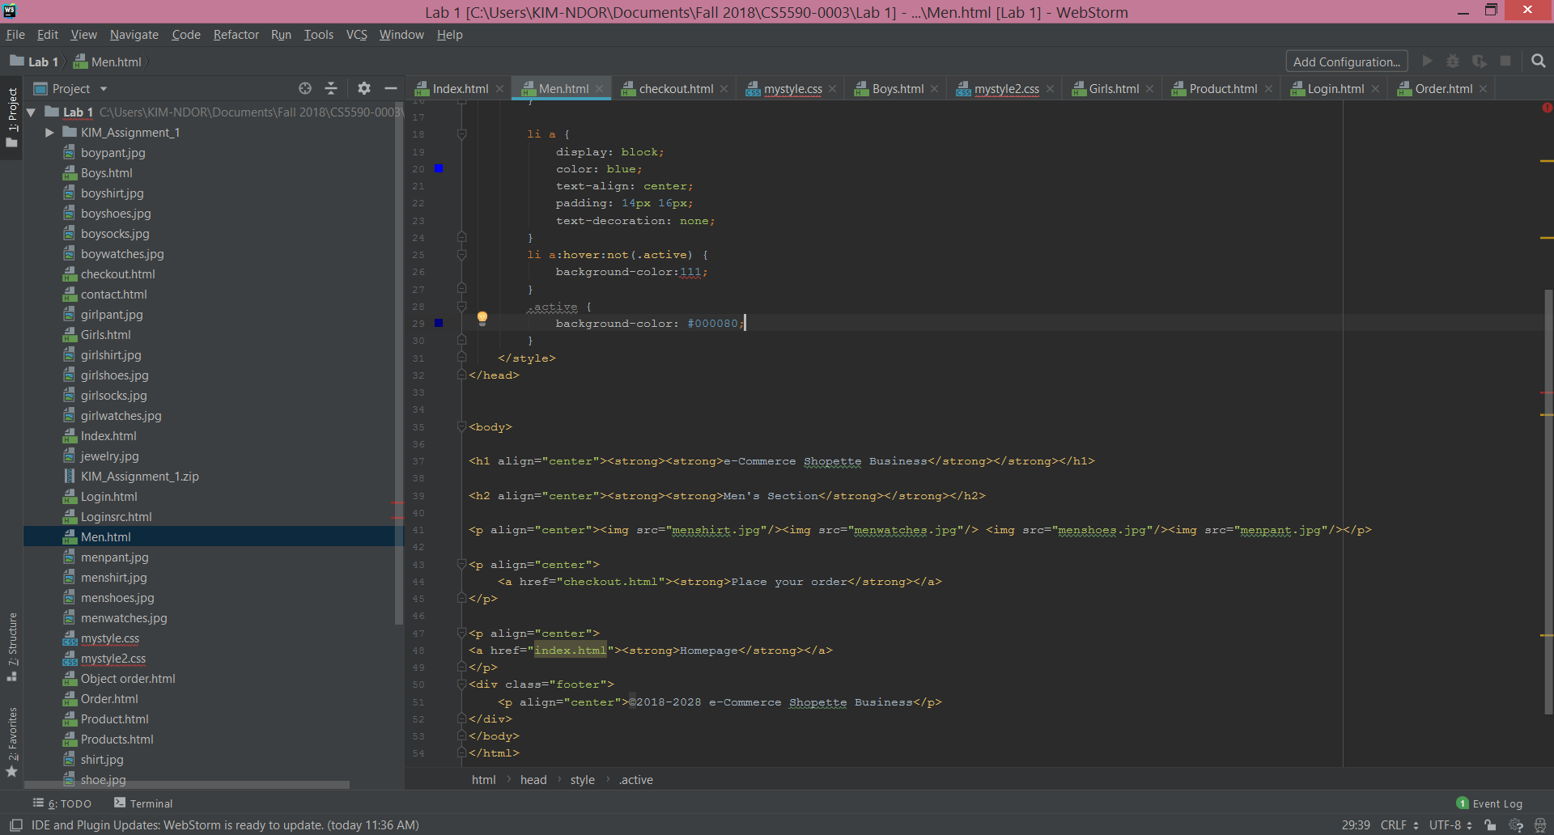

**Women Page**

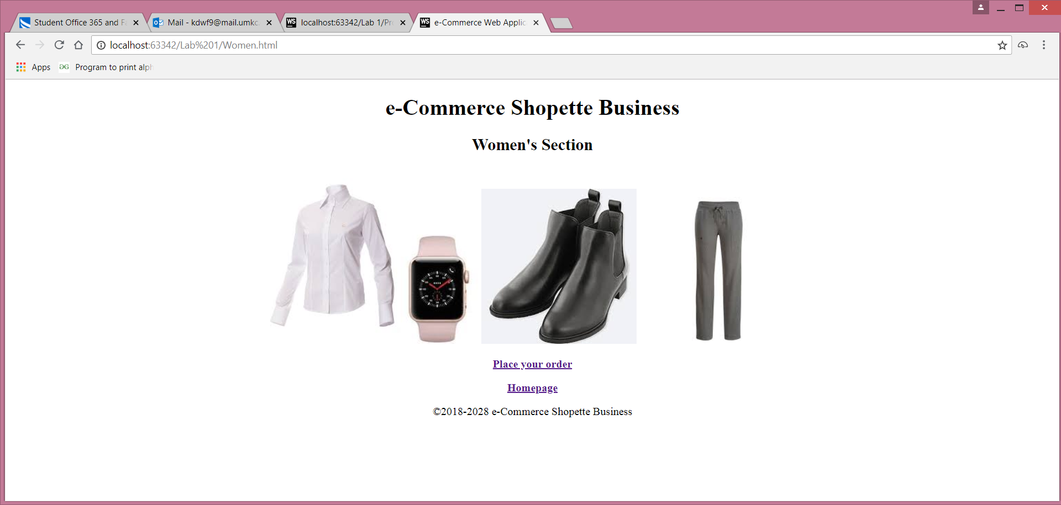

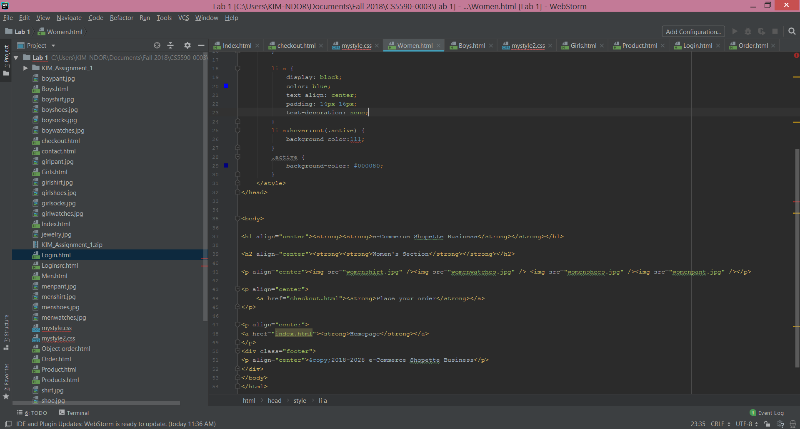

**Boys Page**

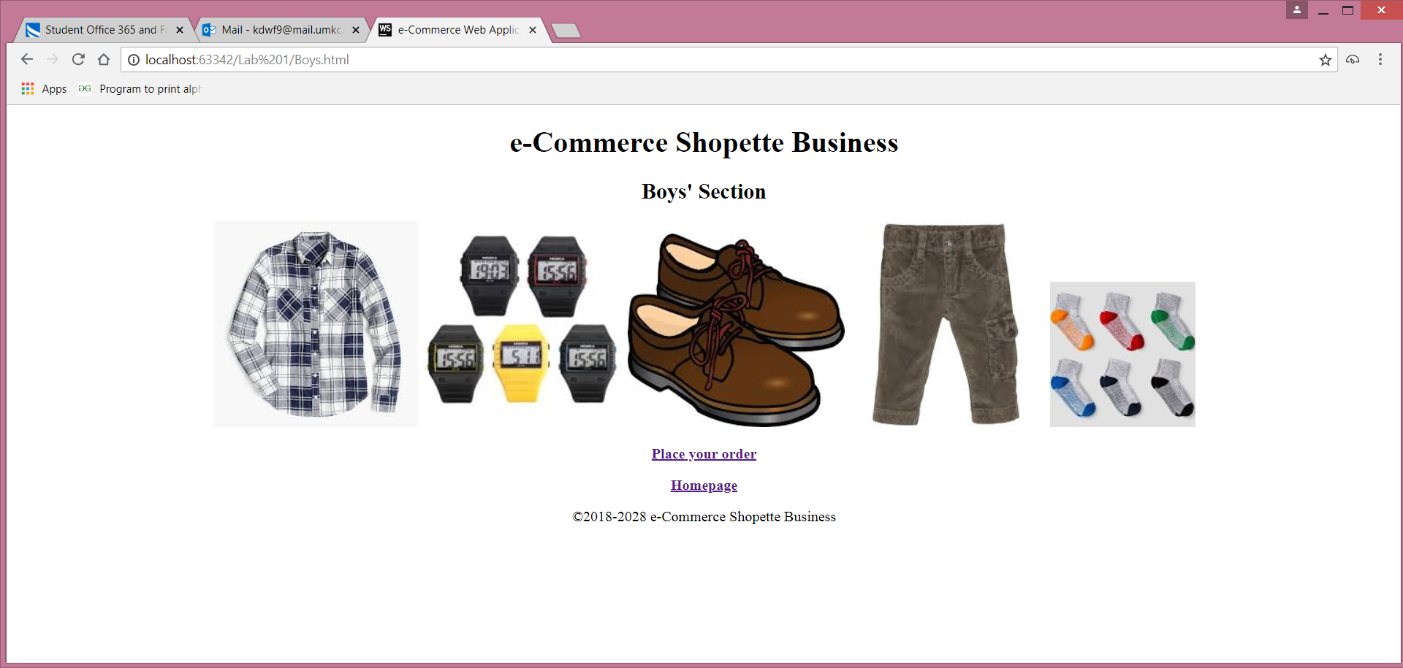

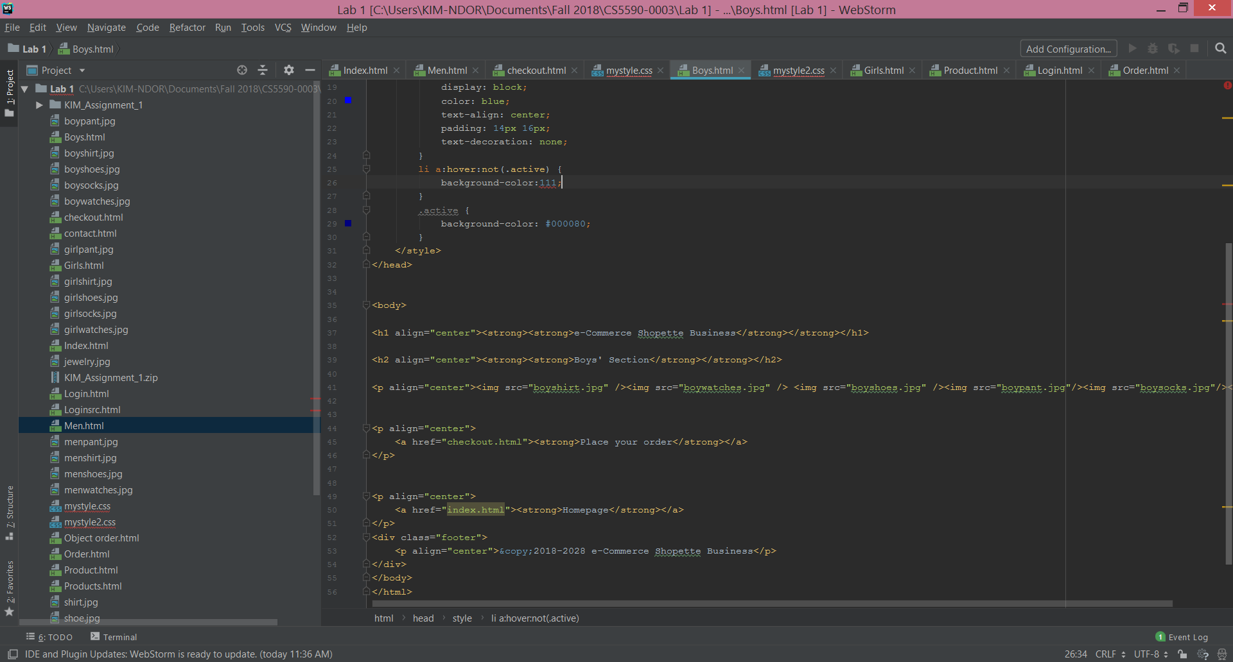

**Girls Page**

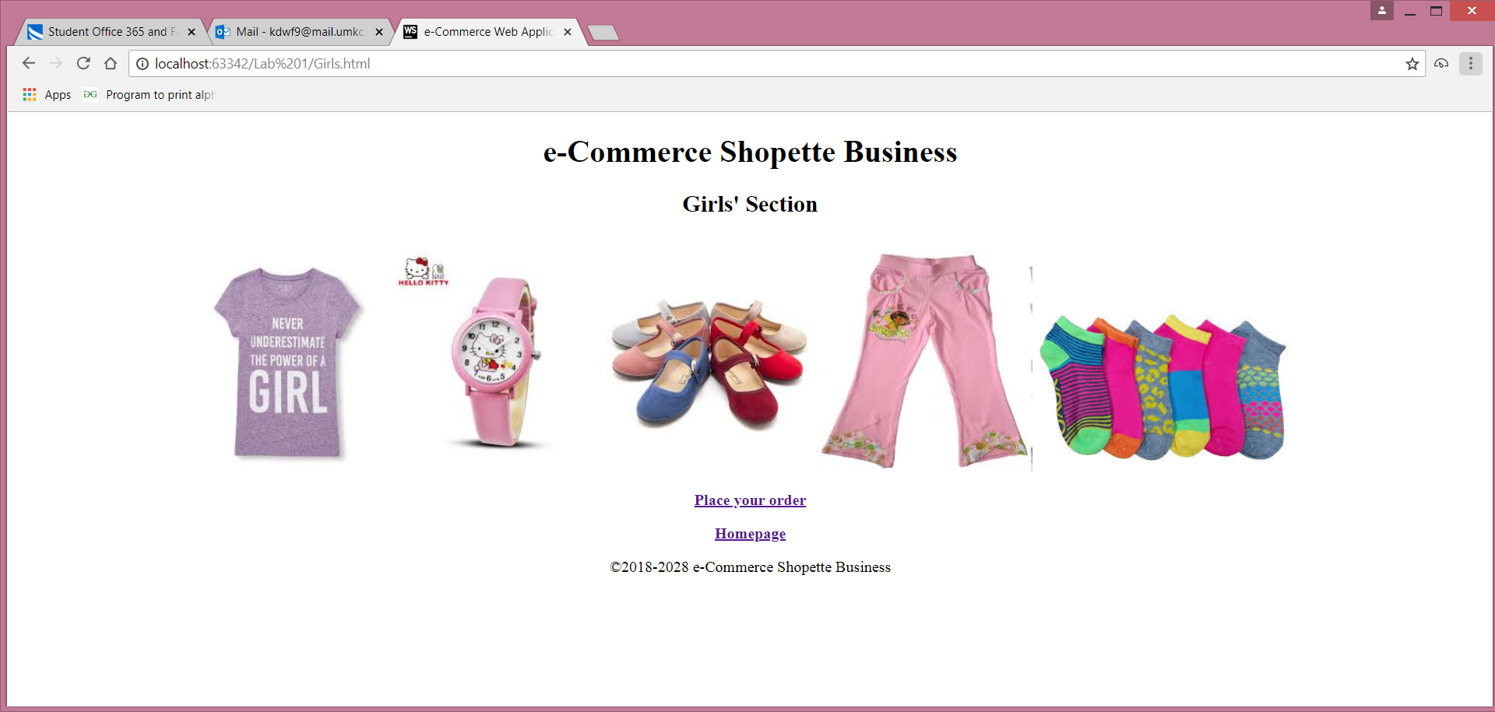

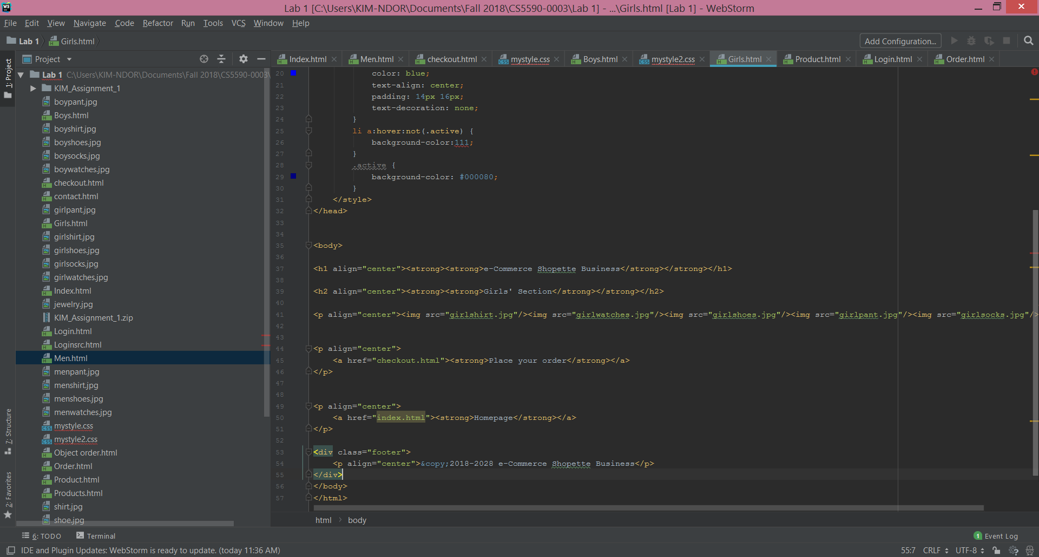

**Contact Page**

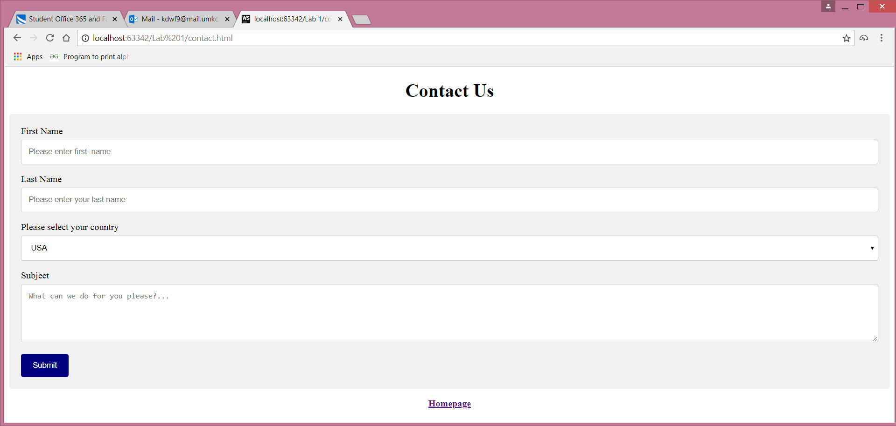

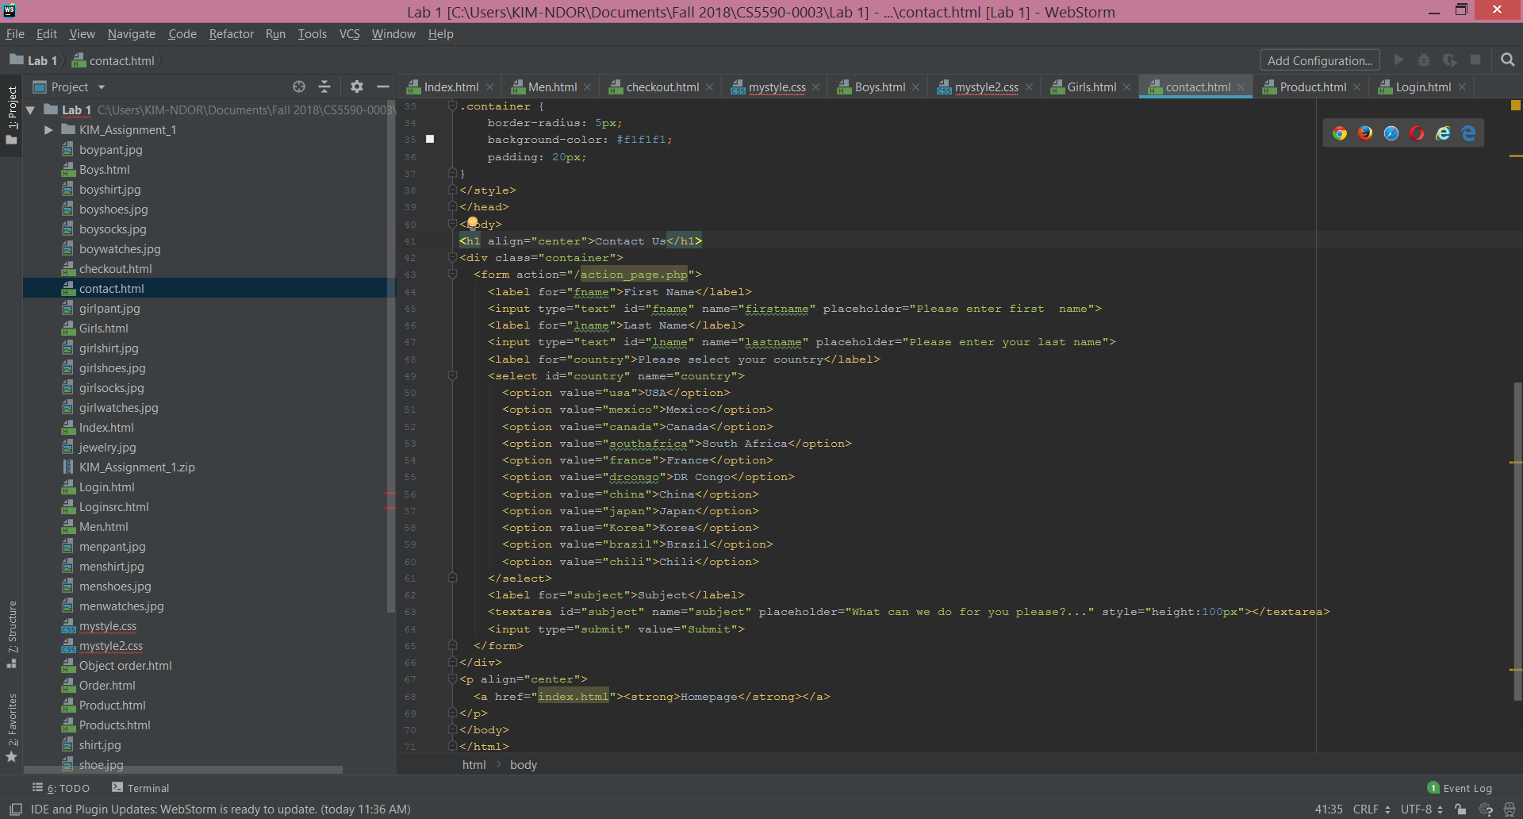

**Order Page**

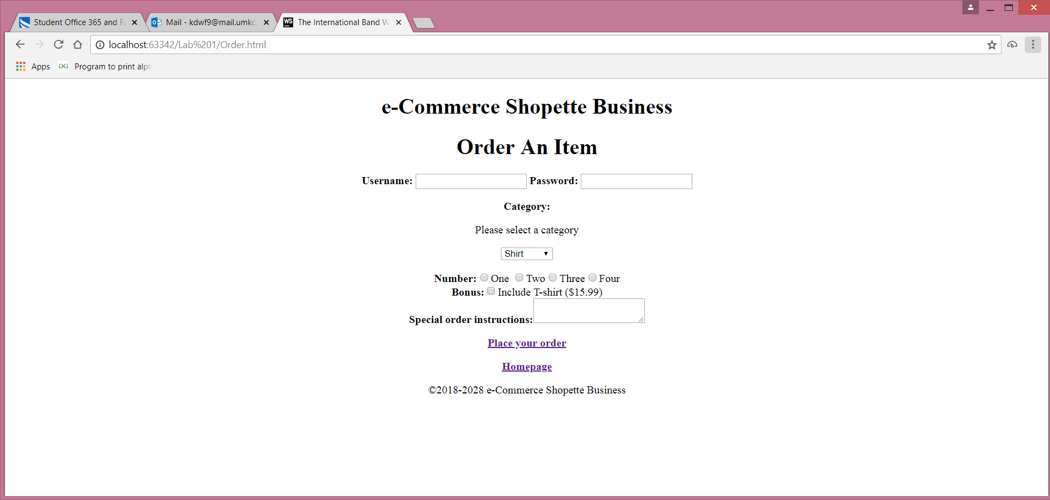

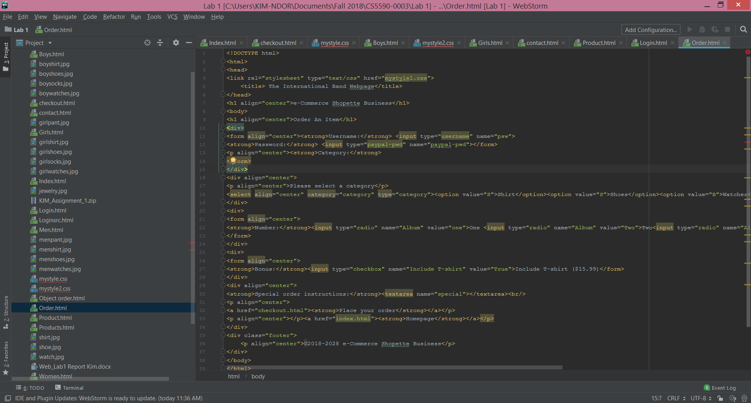

1. **Conclusion**

We built a website to sell manufactured items such as clothing, shoes, and watches nationally and internationally. The sales are exclusively online. The accepted cards are Visa, Mastercard, and Discover. The website is easily accessible for efficient sales activities. There are, however, needs for further designs and improvements.

**Reference**

DOGULIN digital at <https://www.dogulindigital.com.au/importance-of-website-for-business/> accessed on Sep. 11, 2018.

LYFE MARKETING at <https://www.lyfemarketing.com/blog/importance-of-a-website/> accessed on Sep. 12, 2018.